University of Cologne
Module: Verarbeitung von Textdaten

Sentiment Shifts in Public Discourse on Artificial Intelligence: A Corpus-Based Analysis of German News Media (2015–2025)

Seminar paper by Tim Hebestreit
thebestr@smail.uni-koeln.de
Matriculation Number: 7354304

Examiner: Prof. Dr. Nils Reiter

Table of Contents
1. Introduction 1
2. Concepts and Related Work 1
2.1 Concepts 1
2.2 Related Work 1
3. Data 2
3.1 Data collection 2
3.2 Data Preprocessing 2
3.3 Sentiment Analysis 3
4. Results 3
5. Discussion 5
5.1 Key Findings 5
5.2 Limitations 6
6. Conclusion 6
Bibliography 7

1. Introduction
Artificial Intelligence (AI) has evolved from a niche topic to a dominant theme in public discourse. A key starting point for this development was the victory of neural network AlphaGo over Go champion Lee Sedol, (Silver et al., 2016). Following the rise of Large Language Models (LLMs) based on the transformers architecture (Vaswani et al., 2017), interest in the field accelerated rapidly. With the release of generative AI models, such as ChatGPT in November 2022, the technology became accessible to the general public. This accessibility vastly increased the popularity and relevance of AI, not just for private consumers, but also for the media reporting on the topic. The sentiment in this reporting varies significantly, ranging from praising the capabilities of the new technology (Podbregar, 2022) to dystopian warnings of a science-fiction-like future (Drösser, 2026). This raises the question of whether media coverage reflects the technical reality or is driven by hype or fear. Furthermore, reporting in specialised Information Technology (IT) media likely differs from that in general public media aimed at a broader set of readers.
The objective of this thesis is to examine potential sentiment shifts in German media and compare the reporting of general public media to media specialised on the field of IT. For that, a sentiment analysis on a text corpus of German news articles from 2015-2025 is performed.
The structure of the work is as follows. Following this introduction, Chapter 2 defines concepts and lists related work. Chapter 3 describes the data collection and cleaning, as well as the methodology. Chapter 4 presents the results of the analysis, which Chapter 5 discusses in detail. Chapter 6 then concludes the work.

2. Concepts and Related Work
To analyze sentiment shifts in media regarding AI, it is essential to define the underlying terminology and review the state of research.

2.1 Concepts
While early Artificial Intelligence focused on symbolic reasoning and problem-solving methods, modern AI is largely defined by Machine Learning (ML). Recently, deep learning and generative models have reshaped the field (Horvitz & Mitchell, 2024). Unlike traditional ML models that classify data, generative AI (e.g. ChatGPT, Midjourney) creates new content. This capability has shifted AI from an invisible background process to a visible, interactive tool for consumers (Qi et al., 2023).
Sentiment Analysis, a subfield of natural language processing (NLP), computationally classifies opinions in text as positive, negative, or neutral (Pang & Lee, 2008). This thesis applies a sentiment analysis to objectively measure the tone of media coverage across large text corpora.
Regarding types of media outlets thesis distinguishes between specialised IT media (e.g., Heise, Golem) and general public media (e.g. Spiegel, Bild). The former targets professionals and experts in the technology sector and focuses on technical implementation and industry impact, while the latter addresses a broader audience, focusing on ethical questions and on the impact on society and consumers.

2.2 Related Work
The representation of AI in the media has been a subject of academic interest for decades, often following cycles of hype and “AI winters” (Stöckle, 2019). Fast and Horvitz (2017) analysed New York Times articles over thirty years, finding that while discussion of AI increased, the sentiment remained generally optimistic, while concerns about loss of control have risen recently. Studies on media framing suggest that general media tends to anthropomorphise AI to visualize abstract algorithms. This creates narratives driven by fear (e.g. of unemployment) or utopian hype, rather than the technical reality (Bunz & Braghieri, 2022). Specifically in Germany, research documents widespread scepticism toward AI, particularly regarding privacy and personalisation of contents. (Kozyreva et al., 2020). However, the specific impact of the recent generative AI “boom” on the difference in reporting of German specialist IT press and general mass media has not yet been sufficiently explored. This thesis aims to close this gap.

3. Data
This chapter describes the article collection process via the Nexis Uni and Wiso databases, the pre-processing pipeline in Python, and the implementation of the sentiment analysis.

3.1 Data collection
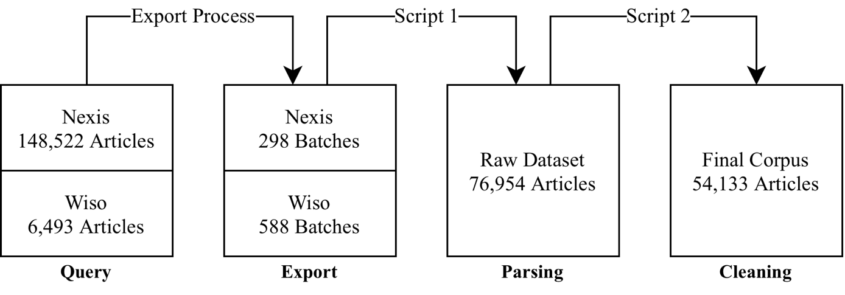
To construct a comprehensive text corpus, two high-quality databases of German news articles were accessed via the University of Cologne’s network: Nexis Uni and Wiso. The data was queried using the search term “Künstliche Intelligenz”, showing articles between November 1, 2015 – November 1, 2025. The collection and cleaning pipeline is visualised in Figure 1.
Figure 1: Data Collection and Processing Pipeline

The primary dataset was sourced from Nexis Uni, which provides over 17,000 sources. There, the above query initially yielded 148,522 German news articles including magazines, press agencies, trade press, transcripts, web news, and blogs. Due to export restrictions, retrieval of the articles required a batch-processing approach. The articles were exported in 298 batches, originally intended to contain 500 articles each. To ensure data quality, batches were verified for completeness, but data loss still occurred in the export process. Although additional search terms such as “ChatGPT” were considered, the query was restricted to “Künstliche Intelligenz” to maintain a consistent baseline across the decade.
As the initial dataset was heavily skewed towards general interest media, a supplementary dataset was queried from the Wiso database. This query was strictly filtered for Specialized Journals in the field of Information Technology. This yielded 6,493 articles stemming from specialized IT sources, ensuring a more balanced representation for the comparative analysis.

3.2 Data Preprocessing
The raw data (588 docx and 117 pdf files, each containing a batch of exported articles) was processed using a custom Python pipeline. First, a parsing script extracted the relevant text body and metadata, saved articles into a Pandas dataframe, and removed cover pages. Subsequently, a second script cleaned the data by removing duplicates, whitespaces, and articles with missing titles or text. This script also formatted the data, removed noise, and created artificial features including Word_Count, Is_IT_Source, Year, and Month.
The final corpus comprises 54,133 unique articles. Table 1 provides a statistical overview of the final dataset, distinguishing between all articles, general press, and IT specialist media. For reproducibility of results, it was uploaded to Zenodo (Hebestreit, 2026).

Table 1: Corpus Statistics
Type of Article | Number of Articles | Average Word Count | Unique Sources
All Articles | 54,133 | 714 | 1,153
General Press | 47,087 | 698 | 1,091
IT Articles | 7,046 | 819 | 62

3.3 Sentiment Analysis
The sentiment analysis was performed using the german-sentiment-bert model (Guhr et al., 2020). This BERT-based model (Devlin et al., 2019) is specifically fine-tuned for German language texts and can be found on Huggingface. It achieves a high F1 Score of 0.963 on benchmark datasets, while still being comparatively small (0.1B parameters). The model is loaded using the transformers library, and the articles are fed into the model in batches of 32 truncated articles with at most 2000 characters, which is enough to capture the sentiment of the article while ensuring computational efficiency. The model classifies each article as positive, neutral, or negative, and provides a confidence score for each prediction.

4. Results
This chapter presents the quantitative results of the sentiment analysis. Table 2 lists the number and share of articles with neutral, positive, and negative sentiment across all articles, IT press, and general press. Notably, the analysis reveals an overwhelming dominance of neutral sentiment (88.07%). Negative sentiment accounts for 11.53%, while the share of articles with positive sentiment is very small. Also, there is a clear difference in source type, with specialised IT press exhibiting an exceptionally high neutrality rate of 95.57%. In contrast, the general press, while still largely neutral (86.95%), is three times more likely to express negative sentiment (12.60% vs. 4.34%).
Table 2: Sentiment overview of the entire corpus.
Sentiment | All Articles | All Articles % | General Press | General Press % | IT Press | IT Press %
Neutral | 47,676 | 88.07% | 40,942 | 86.95% | 6,734 | 95.57%
Positive | 218 | 0.40% | 212 | 0.45% | 6 | 0.09%
Negative | 6,239 | 11.53% | 5,933 | 12.60% | 306 | 4.34%

In addition, Table 3 shows the yearly evolution of the share of sentiment, along with the average confidence value, which quantifies how certain the model was on average in that year.
Table 3: Yearly article count, sentiment evolution and model confidence.
Year | All Articles | Neutral % | Negative % | Positive % | Average Confidence
2015 | 87 | 81.61 | 18.39 | 0.0 | 0.93
2016 | 1168 | 81.68 | 17.47 | 0.86 | 0.93
2017 | 2352 | 85.93 | 13.78 | 0.3 | 0.94
2018 | 4215 | 87.78 | 11.81 | 0.4 | 0.95
2019 | 4269 | 89.13 | 10.61 | 0.26 | 0.96
2020 | 3023 | 89.22 | 10.59 | 0.2 | 0.95
2021 | 3167 | 90.62 | 9.06 | 0.32 | 0.96
2022 | 3203 | 88.92 | 10.62 | 0.47 | 0.96
2023 | 9251 | 85.82 | 13.62 | 0.56 | 0.94
2024 | 11603 | 88.56 | 11.01 | 0.42 | 0.95
2025 | 11795 | 88.98 | 10.67 | 0.35 | 0.95

Figure 2 further explores the distribution of articles across the timeframe by displaying the share of articles per source type and per sentiment. The figure shows that the volume of articles has increased substantially in recent years, with a notable rise in general press articles starting around 2023.
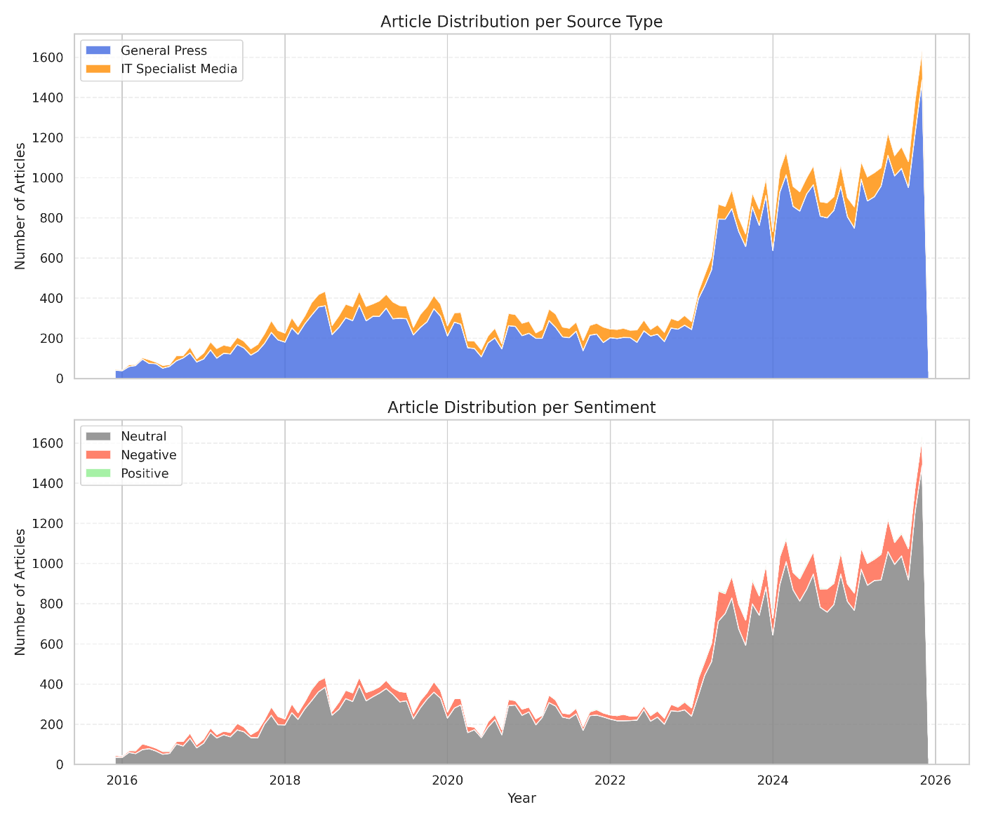
Figure 2: Article Distribution per Sentiment and Source Type. The top panel explores the distribution of articles across general press (blue) and specialised IT press (orange). The bottom panel shows the distribution per sentiment, with articles with neutral sentiment displayed as grey, positive as green, and negative as red.
Figure 3 explores the temporal distribution per articles classified as neutral, negative, or positive. Each subplot displays the rolling average over 6 months to reduce noise and create a smoother curve. Along with the sentiment share for general (blue) and IT press (orange) sources, the average share of all articles is plotted for reference (grey). The figure shows that across the entire timeframe, the share of articles with neutral sentiment is larger for the specialised IT press, and the share of articles with non-neutral sentiment is larger for the general press. Further, it is striking that the share of articles with neutral sentiment increased in the first years of the analysis, while the share of non-neutral articles decreased. And, around 2023 there was a dip in the share of neutral articles, while the share of non-neutral articles peaked, particularly for general press articles.

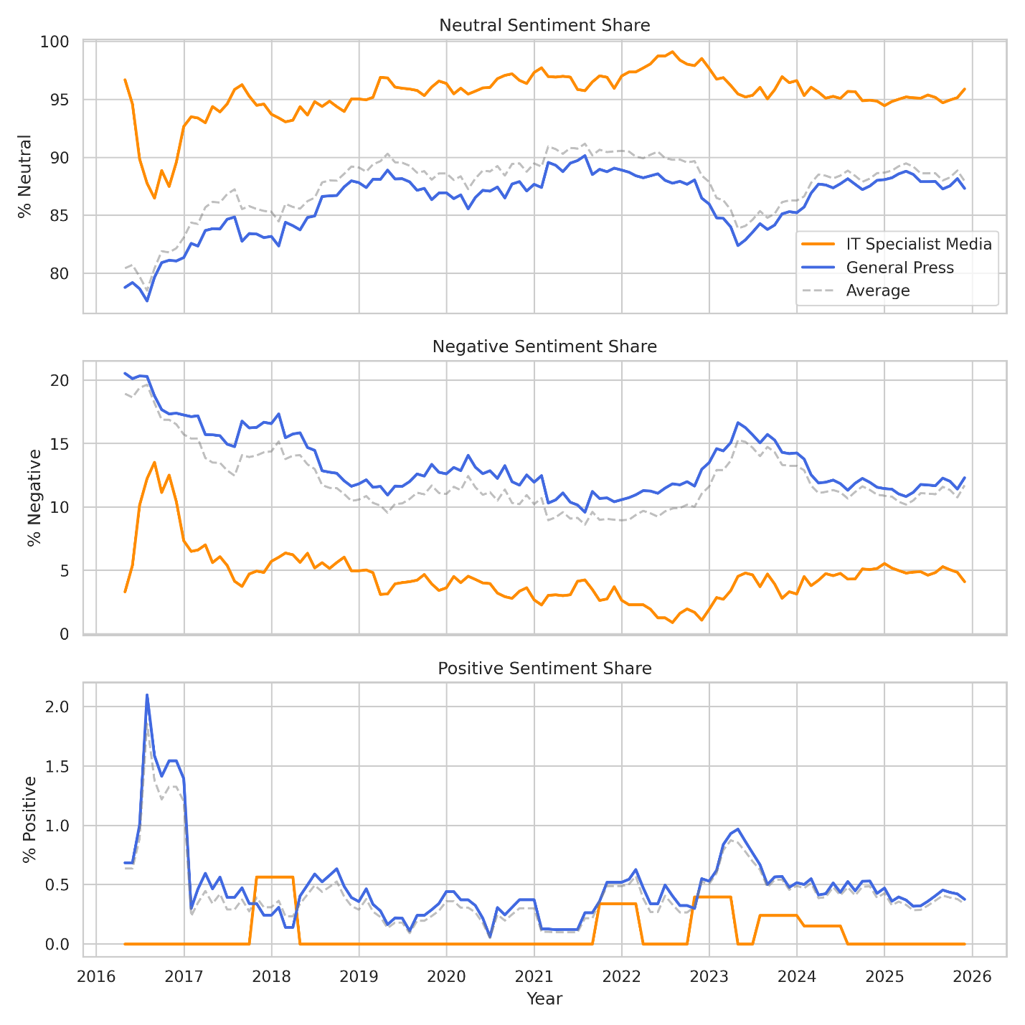
Figure 3: Evolution of Neutral, Negative, and Positive Sentiment. The orange line portays the share of articles from specialised IT press, and the blue line the share of articles from general press. The dotted grey line indicates the average share from all articles. The rolling average of 6 months was used.

5. Discussion
The objective of this thesis was to analyse sentiment shifts in German media regarding AI and compare the reporting of specialised IT media with the general public media. The results reveal several patterns in how AI has been framed over the last decade. This chapter interprets these findings and discusses limitations.

5.1 Key Findings
Generally, the high confidence scores of the model (>0.93) indicates a robust classification. A key finding of this study is the dominance of neutral sentiment across the entire corpus (88.07%), which contradicts the common assumption that media coverage is primarily driven by polarisation. This suggests that most reporting on AI, whether in general or specialist media, is informational and likely presents model releases, business announcements, or neutral factual descriptions of technology. However, among the non-neutral articles, there is a clear bias towards negativity (11.53%) instead of positivity (0.40%). This indicates that in journalism, potential risks (e.g. loss of jobs, surveillance) are considered more newsworthy than gradual technical improvements. The negligible share of positive articles suggests that optimism in technical reporting is often phrased in descriptive terms (e.g. “efficient”, “faster”), which the model classifies as neutral rather than emotionally positive.
The comparison between source types confirms a significant divergence between IT and general media. The IT press acts as more of a rational reporter with an exceptionally high neutrality rate (95.57%). This supports the assumption that IT media focuses on the technical reality that the readership of IT magazines typically seeks (e.g. implementation details, benchmarks), while being less focused on broad societal debates and the emotional cycles of hype and fear. In contrast to that, general public media, while still largely neutral in reporting (86.95%), is nearly three times more likely to express negative sentiment. This signals that when the topic of AI enters public discourse, it is framed more critically. General press coverage focuses less on the technology and more on the implications on society, which invites more scepticism and fear-based narratives. Thus, the “dystopian” sentiment mentioned in the introduction is primarily a phenomenon of the general press, and less of IT media.
The temporal analysis highlights a significant shift around 2023, coinciding with the rise of generative AI models like ChatGPT. Before 2023, the share of neutral articles was rising, which suggests that AI was becoming more of a background technology. However, the dip in neutrality and simultaneous peak in non-neutral (mostly negative) sentiment in 2023 along with the sharp increase in article volume indicates a key disruption, with AI moving from a niche topic to a mainstream concern. The associated increase in negative sentiment suggests that the increasingly tangible nature of generative AI led to concrete fears (e.g. replacement of creative jobs) that were less present with earlier, less adopted forms of AI. This reaction was much more noticeable in the general press, further indicating a gap between technical reporting and public perception.

5.2 Limitations
While the results provide clear insights, limitations of the methodology must be considered. The extremely low number of positive classifications (0.40%) could point to a limitation in the underlying sentiment model or the dictionary used. If the model is trained to recognize emotional words (e.g. “happy”, “excellent”), it might fail to capture technical optimism usually expressed through terms like “efficient” or “innovative”. Regarding dataset size, while 54,133 articles should suffice for the scope of this analysis, more articles could have led to an even more robust comparison. Dataset size could have been increased by searching for articles containing model names like “ChatGPT”, or anglicisms like “Artificial Intelligence” in addition to “Künstliche Intelligenz”. Finally, a higher share of IT articles would have further balanced out the dataset and allow for an even more robust comparison.

6. Conclusion
This thesis investigated the evolution of German media sentiment regarding AI from 2015 – 2025. By analysing a corpus of over 54,000 news articles, the study showed that contrary to the perception of a discourse driven primarily by hype and fear, the majority of reporting remains neutral and informational.
However, a divide between media types was identified. While the specialised IT press maintains a factual and rational tone, the general public media is more significantly more prone to negative framing. This confirms that “dystopian” narratives are largely present in public discourse rather than technical reporting and discussion. Furthermore, the analysis identified the rise of generative AI in 2023 as a paradigm shift. This period marked not only an explosion in media coverage but also a memorable shift towards more critical coverage in the general press.
Ultimately, this study highlights the importance of distinguishing between specialised IT reporting and general public discourse, especially as AI technologies are becoming more capable and tangible. Different media types often portray different perspectives on the same technology. Recognising this difference is essential to understand the full picture, which can help in separating the technical reality from the societal fears surrounding it.

Bibliography
Bunz, M., & Braghieri, M. (2022). The AI doctor will see you now: assessing the framing of AI in news coverage. AI & society, 37, 9–22. https://doi.org/10.1007/s00146-021-01145-9
Devlin, J., Chang, M.-W., Lee, K., & Toutanova, K. (2019). BERT: Pre-training of deep bidirectional transformers for language understanding. Proceedings of the 2019 Conference of the North American Chapter of the Association for Computational Linguistics: Human Language Technologies (NAACL-HLT 2019), 4171–4186. Association for Computational Linguistics. https://doi.org/10.48550/arXiv.1810.04805
Drösser, C. (2026). Mensch und KI: Wer steuert wen? Online article from deutschlandfunkkultur.de. Retrieved on 11.1.2026 from https://www.deutschlandfunkkultur.de/kuenstliche-intelligenz-ki-mensch-kontrolle-100.html
Fast, E., & Horvitz, E. (2017). Long-Term Trends in the Public Perception of Artificial Intelligence. Proceedings of the AAAI Conference on Artificial Intelligence, 31(1). https://doi.org/10.1609/aaai.v31i1.10635
Guhr, O., Schumann, A.-K., Bahrmann, F., & Böhme, H. J. (2020). Training a broad-coverage German sentiment classification model for dialog systems. In Proceedings of the 12th Language Resources and Evaluation Conference (pp. 1620–1625). European Language Resources Association. https://www.aclweb.org/anthology/2020.lrec-1.202
Hebestreit, T. (2026). German News Article Dataset - Seminar Paper Tim Hebestreit [Data set]. Zenodo. https://doi.org/10.5281/zenodo.18236684
Horvitz, E., & Mitchell, T. M. (2024). Scientific progress in artificial intelligence: History, status, and futures. In Realizing the promise and minimizing the perils of AI for science and the scientific community. University of Pennsylvania Press. https://erichorvitz.com/AI_Overview_History_Status_Futures_February_2024.pdf
Kozyreva, A., Herzog, S., Lorenz-Spreen, P., Hertwig, R., & Lewandowsky, S.(2020). Artificial intelligence in online environments: Representative survey of public attitudes in Germany. Berlin: Max Planck Institute for Human Development. https://doi.org/10.17617/2.3188061.
Pang, B., & Lee, L. (2008). Opinion mining and sentiment analysis (pre-publication version). https://www.cs.cornell.edu/home/llee/omsa/omsa.pdf
Podbregar, N. (2022). Künstliche Intelligenz meistert Diplomatie. Online article from scinexx.de. Retrieved on 11.1.2026 from https://www.scinexx.de/news/technik/kuenstliche-intelligenz-meistert-diplomatie/
Silver, D., Huang, A., Maddison, C. et al. (2016). Mastering the game of Go with deep neural networks and tree search. Nature 529, 484–489 (2016). https://doi.org/10.1038/nature16961
Stöckle, J. (2019). AI in the hype cycle – A brief history of AI. Alexander von Humboldt Institut für Internet und Gesellschaft. Zenodo. https://doi.org/10.5281/zenodo.3254838
Qi, W., Pan, J., Lyu, H., Luo, J. (2023). Excitements and concerns in the post-ChatGPT era: An information-centric exploration of public perceptions. arXiv preprint arXiv:2307.05809. https://arxiv.org/abs/2307.05809​
Vaswani, A., Shazeer, N., Parmar, N., Uszkoreit, J., Jones, L., Gomez, A. N., Kaiser, Ł., & Polosukhin, I. (2017). Attention is all you need. Advances in Neural Information Processing Systems, 30, 5998–6010. https://arxiv.org/abs/1706.03762

Data, code, and figures for this thesis are available on JupyterLab available via the University of Cologne’s network (http://compute.spinfo.uni-koeln.de/hub/user-redirect/lab/tree/Hausarbeit%20Tim%20Hebestreit), or inside this Github Repository (https://github.com/timheb16/german-news-articles-sentiment). Please note that the dataset is too large for Github and is stored on Zenodo (Hebestreit, 2026).
Again, scripts can be found on JupyterLab available via the University of Cologne’s network (http://compute.spinfo.uni-koeln.de/hub/user-redirect/lab/tree/Hausarbeit%20Tim%20Hebestreit), or inside this Github Repository (https://github.com/timheb16/german-news-articles-sentiment).

